INTRODUCTION:

This project aims to analyse UNESCO World Heritage sites, focusing on India's sites, using Tableau for data visualization and exploration. The introduction will establish the significance of UNESCO World Heritage Sites, highlight India's rich heritage, and outline the project's purpose: to provide an interactive and insightful exploration of these sites through Tableau dashboards.

UNESCO (United Nations Educational, Scientific and Cultural Organization) designates World Heritage Sites to recognize and protect locations of outstanding universal value for their cultural, historical, scientific, or other forms of significance. These sites are not only crucial for preserving cultural and natural heritage but also play a vital role in promoting cultural understanding and sustainable development.

India, with its diverse and ancient civilization, boasts a remarkable collection of UNESCO World Heritage Sites. These sites, including architectural marvels like the [Taj Mahal](https://www.google.com/search?client=firefox-b-d&cs=0&sca_esv=e80e085d87ffeffa&q=Taj+Mahal&sa=X&ved=2ahUKEwigmJ_juYqPAxUNVWwGHd8DLPQQxccNegQIFhAB&mstk=AUtExfCVujnzXzbBHJuBGP4JLOY5--Wh3ud7lVAkssXswkLam2D7RAH2UaKw59ytCPhsF-ZONefHj2_Qd1nULmKSKDTVGucDLxudmnJrTWjWT_ZITqBKIGA4qCtlyXgYhDXzAxA&csui=3) and [Ajanta Caves](https://www.google.com/search?client=firefox-b-d&cs=0&sca_esv=e80e085d87ffeffa&q=Ajanta+Caves&sa=X&ved=2ahUKEwigmJ_juYqPAxUNVWwGHd8DLPQQxccNegQIFhAC&mstk=AUtExfCVujnzXzbBHJuBGP4JLOY5--Wh3ud7lVAkssXswkLam2D7RAH2UaKw59ytCPhsF-ZONefHj2_Qd1nULmKSKDTVGucDLxudmnJrTWjWT_ZITqBKIGA4qCtlyXgYhDXzAxA&csui=3), natural wonders like the [Western Ghats](https://www.google.com/search?client=firefox-b-d&cs=0&sca_esv=e80e085d87ffeffa&q=Western+Ghats&sa=X&ved=2ahUKEwigmJ_juYqPAxUNVWwGHd8DLPQQxccNegQIFhAD&mstk=AUtExfCVujnzXzbBHJuBGP4JLOY5--Wh3ud7lVAkssXswkLam2D7RAH2UaKw59ytCPhsF-ZONefHj2_Qd1nULmKSKDTVGucDLxudmnJrTWjWT_ZITqBKIGA4qCtlyXgYhDXzAxA&csui=3), and historical sites like [Agra Fort](https://www.google.com/search?client=firefox-b-d&cs=0&sca_esv=e80e085d87ffeffa&q=Agra+Fort&sa=X&ved=2ahUKEwigmJ_juYqPAxUNVWwGHd8DLPQQxccNegQIFhAE&mstk=AUtExfCVujnzXzbBHJuBGP4JLOY5--Wh3ud7lVAkssXswkLam2D7RAH2UaKw59ytCPhsF-ZONefHj2_Qd1nULmKSKDTVGucDLxudmnJrTWjWT_ZITqBKIGA4qCtlyXgYhDXzAxA&csui=3), showcase India's rich history, artistic brilliance, and ecological diversity. They represent a testament to India's contribution to global heritage and its commitment to preserving its cultural and natural treasures.

This project delves into the world of UNESCO World Heritage Sites, specifically focusing on those in India, through the lens of [data visualization](https://www.google.com/search?client=firefox-b-d&cs=0&sca_esv=e80e085d87ffeffa&q=data+visualization&sa=X&ved=2ahUKEwigmJ_juYqPAxUNVWwGHd8DLPQQxccNegQIIhAB&mstk=AUtExfCVujnzXzbBHJuBGP4JLOY5--Wh3ud7lVAkssXswkLam2D7RAH2UaKw59ytCPhsF-ZONefHj2_Qd1nULmKSKDTVGucDLxudmnJrTWjWT_ZITqBKIGA4qCtlyXgYhDXzAxA&csui=3) using Tableau. By leveraging Tableau's capabilities, this project aims to create interactive dashboards that allow users to explore these sites in-depth, uncovering details about their history, architectural styles, cultural significance, and geographical distribution. This interactive approach will enable users to gain a deeper appreciation for the diversity and richness of India's heritage and the importance of its preservation.

## 1.1 Project overview:

This analysis will delve into various aspects of UNESCO World Heritage Sites, using Tableau as a key tool for data exploration and presentation. The project will:

* **Explore the geographic distribution and classification of sites:** Understanding the regional and thematic representation of World Heritage Sites across the globe.
* **Analyze key characteristics and attributes:** Examining factors such as the type of site (cultural, natural, or mixed), their significance (historical, architectural, ecological, etc.), and the criteria for inscription on the list.
* **Investigate threats and challenges to preservation:** Highlighting the pressures facing these sites, including climate change, urbanization, conflict, and inadequate management.
* **Examine conservation and management efforts:** Exploring the strategies and initiatives implemented to safeguard these sites, including the role of international cooperation and local community engagement.
* **Highlight the role of heritage interpretation and sustainable tourism:** Understanding how these aspects contribute to raising awareness, promoting cultural understanding, and generating economic benefits for local communities while ensuring the long-term preservation of the sites.
* **Showcase best practices and case studies:** Presenting examples of successful management practices and innovative approaches to heritage preservation from around the world.

This in-depth analysis will serve as a valuable resource for researchers, policymakers, educators, and anyone interested in gaining a deeper understanding of UNESCO World Heritage Sites and the critical importance of their preservation.

## 1.2 Purpose:

# How to Find Your Purpose

The primary purpose of this in-depth analysis of UNESCO World Heritage Sites in Tableau is to leverage the power of data visualization to **reveal actionable insights** that contribute to a deeper understanding, appreciation, and ultimately, the **more effective preservation and management of these irreplaceable cultural and natural treasures**.

More specifically, this project aims to:

1. **Promote Enhanced Awareness:** By creating interactive and easily digestible visualizations, this analysis will make the complex data surrounding World Heritage Sites accessible to a broader audience, fostering greater awareness of their significance, the threats they face, and the importance of their preservation.
2. **Uncover Hidden Trends and Patterns:** Utilizing Tableau's analytical capabilities, the project will explore spatial, temporal, and thematic patterns within the data, identifying potential correlations between factors such as location, site category, threats, and conservation efforts. This could include revealing patterns related to the geographic distribution of sites, the prevalence of certain threats in specific regions, or the effectiveness of particular conservation strategies.
3. **Support Informed Decision-Making:** By providing clear and concise visualizations, this analysis will empower policymakers, heritage managers, researchers, and other stakeholders with data-driven insights to develop more effective strategies for:
   * **Prioritizing conservation efforts** based on the vulnerability and significance of sites.
   * **Developing sustainable tourism models** that balance economic benefits with preservation needs.
   * **Strengthening international cooperation and capacity-building initiatives**.
   * **Adapting to emerging challenges** such as climate change, urbanization, and conflict.
4. **Foster a Deeper Appreciation for Global Heritage:** Through engaging visualizations and a comprehensive exploration of the data, the project will highlight the incredible diversity and value of the world's heritage, inspiring a sense of shared responsibility for its protection and encouraging greater engagement with these sites, both physically and virtually.

5. Ultimately, this Tableau-based analysis strives to go beyond mere data presentation, providing a dynamic and insightful resource that actively contributes to safeguarding our collective heritage for future generations.

2. IDEATION PHASE:

This response explores how UNESCO World Heritage Sites can be analyzed and visualized using Tableau, focusing on the ideation process and problem statements relevant to such a project. It delves into the types of data involved, potential insights, and the value of visualizing this data.

Ideation Process:

1. **1. Define the Scope:**

Begin by clearly defining the scope of the project. This could be a specific region, a particular type of heritage site (cultural, natural, or mixed), or a thematic focus (e.g., religious sites, ancient cities, biodiversity hotspots).

1. **2. Data Collection:**

Gather relevant data about the chosen sites. This typically includes:

* + **General Information:** Site name, location (latitude/longitude), inscription date, category (cultural, natural, mixed), and brief description.  • **Attributes:** Unique characteristics like architectural styles, historical periods, biodiversity information (flora, fauna), geological features, etc.
  + • **Visitor Data:** Number of visitors, demographics, seasonality, etc.
  + • **Management and Conservation Data:** Information about the management authority, conservation efforts, threats, and restoration projects.
  + • **Financial Data:** Budgets, funding sources, and economic impac

**3 . Data Cleaning and Preparation:** Clean and prepare the data for Tableau. This may involve:

* + **Standardizing formats:** Ensuring consistent date formats, units of measurement, etc.
  + • **Creating calculated fields:** Deriving new variables from existing data (e.g., calculating the age of a site, visitor density, etc.).
  + • **Joining datasets:** Combining data from different sources.

**4. Tableau Workbook Setup:**

* **Create a new Tableau workbook:** Start with a blank canvas.
* • **Connect to the data sources:** Import the prepared data into Tableau.

• **Design the dashboard layout:** Plan the structure of the dashboard, including the placement of visualizations, filters, and text elements.

**5. Visualization Design:**

* **Choose appropriate chart types:** Select visualizations that effectively convey the data. Examples include:
  + **Maps:** Displaying the geographical distribution of sites, highlighting clusters, and showing proximity to other locations or landmarks.

• **Bar charts/Histograms:** Comparing the number of sites by category (cultural, natural, mixed) or by region.

• **Line charts:** Tracking visitor numbers over time, showing trends in conservation efforts, or mapping the spread of a particular architectural style.

• **Scatter plots:** Exploring relationships between variables, such as visitor numbers and site age, or visitor numbers and conservation expenditure.

• **Treemaps:** Visualizing the relative size or importance of different sites or categories within a larger hierarchy.

• **Waffle charts:** Showing the percentage of sites with specific characteristics.

• **Use color effectively:** Employ color to differentiate categories, highlight trends, and draw

attention to key information.

• **Add interactive elements:** Include filters, drill-downs, and tooltips to allow users to explore the data in more detail.

**6. Storytelling:**

* **Develop a narrative:** Use the visualizations to tell a story about the World Heritage Sites, highlighting their significance, challenges, and potential.

• **Provide context:** Add text annotations, captions, and descriptions to explain the visualizations and provide background information.

• **Consider the target audience:** Tailor the dashboard to the specific needs and interests of the intended users.

• **7. Testing and Refinement:**

Test the dashboard with potential users, gather feedback, and refine the visualizations and narrative accordingly.

Code:

# UNESCO World Heritage Sites Data Prep for Tableau

import pandas as pd

import requests

import re

from pathlib import Path

# 1. Download UNESCO dataset (CSV export from UNESCO website)

unesco\_url = "https://whc.unesco.org/en/list/csv" # Example placeholder

csv\_path = Path("unesco\_sites.csv")

if not csv\_path.exists():

r = requests.get(unesco\_url)

csv\_path.write\_bytes(r.content)

# 2. Load UNESCO data

df = pd.read\_csv(csv\_path)

# Inspect columns

print(df.columns)

# 3. Normalize category

def normalize\_category(cat):

if isinstance(cat, str):

if cat.startswith("C"):

return "Cultural"

elif cat.startswith("N"):

return "Natural"

else:

return "Mixed"

return None

df["Category\_Normalized"] = df["category"].apply(normalize\_category)

# 4. Extract criteria flags (i–x)

criteria\_cols = ["crit\_i","crit\_ii","crit\_iii","crit\_iv","crit\_v",

"crit\_vi","crit\_vii","crit\_viii","crit\_ix","crit\_x"]

for idx, roman in enumerate(["i","ii","iii","iv","v","vi","vii","viii","ix","x"]):

df[criteria\_cols[idx]] = df["criteria\_txt"].apply(lambda x: bool(re.search(rf"\({roman}\)", str(x).lower())))

# 5. Normalize danger flag

df["Danger\_Flag"] = df["danger\_list"].fillna("").str.strip().str.lower().eq("yes")

# 6. Load country metadata (population & area) from World Bank

pop\_df = pd.read\_csv("https://raw.githubusercontent.com/datasets/population/master/data/population.csv")

area\_df = pd.read\_csv("https://raw.githubusercontent.com/datasets/geo-countries/master/data/countries.geojson")

# (Optional) You might need to transform area\_df to get country\_code, area\_km2

# Example: filter latest population year

latest\_pop\_year = pop\_df["Year"].max()

pop\_latest = pop\_df.query("Year == @latest\_pop\_year")[["Country Code", "Value"]]

pop\_latest.columns = ["country\_code", "Population"]

# Merge with UNESCO data

df = df.merge(pop\_latest, left\_on="iso\_code", right\_on="country\_code", how="left")

# 7. Compute density metrics

df["Sites\_per\_Million\_Pop"] = df.groupby("country\_code")["id\_number"].transform("count") / (df["Population"] / 1\_000\_000)

# 8. Save cleaned CSV for Tableau

output\_csv = Path("unesco\_sites\_clean.csv")

df.to\_csv(output\_csv, index=False)

print(f"Clean data saved to {output\_csv}")

# 9. (Optional) Export to Tableau .hyper using tableauhyperapi

"""

from tableauhyperapi import HyperProcess, Connection, Telemetry, TableDefinition, SqlType, TableName, Inserter, CreateMode

# Example code to write df to .hyper for Tableau:

with HyperProcess(telemetry=Telemetry.SEND\_USAGE\_DATA\_TO\_TABLEAU) as hyper:

with Connection(endpoint=hyper.endpoint, database="unesco.hyper", create\_mode=CreateMode.CREATE\_AND\_REPLACE) as connection:

table = TableDefinition(TableName("public", "unesco\_sites"), ...)

connection.catalog.create\_table(table)

with Inserter(connection, table) as inserter:

inserter.add\_rows(rows\_from\_df(df))

inserter.execute()

"""

## 2.1 Problem statement:

UNESCO World Heritage Sites represent significant cultural and natural treasures of humanity. However, existing data on these sites is often scattered across multiple sources, inconsistently formatted, and difficult to analyse in an interactive way. Stakeholders — including researchers, policymakers, conservationists, and educators — face challenges in identifying trends, assessing conservation status, and understanding global distribution patterns. This lack of a unified, visual analytics platform leads to fragmented insights, delays in decision-making, and missed opportunities for awareness and preservation efforts.

The project aims to address this gap by developing a **Tableau-based interactive dashboard**, powered by a clean and enriched dataset prepared in Python, to enable multi-dimensional exploration of UNESCO World Heritage Sites by location, type, inscription year, and conservation status.

## 2.2 Empathy Map Canvas:

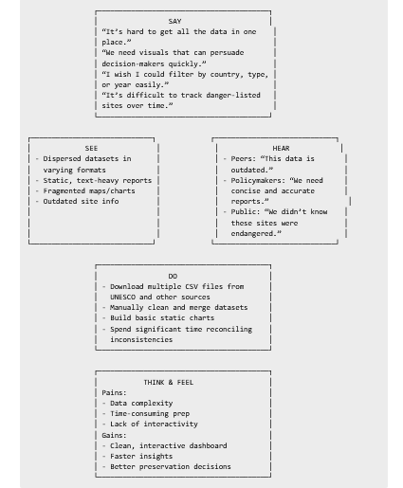

**1. Who are we empathizing with?**

* **Primary Users:** Cultural heritage researchers, UNESCO analysts, policymakers, conservation NGOs, educators, students.
* **Secondary Users:** Tourists, travel planners, general public interested in heritage.

**2. What do they need to do?**

* Compare and analyse UNESCO sites by country and category.
* Identify and track at-risk sites.
* Detect trends over decades.
* Communicate findings clearly to multiple audiences.

**3. Insights from Map**

* **Pain Points:** Disconnected data sources, outdated info, slow analysis.
* **Desired Gains:** One-click filtering, automated updates, engaging visuals, evidence-based decision-making.

1. **Implication for Project Design** This empathy map drives the project’s core requirement: a single, interactive Tableau platform, with regularly updated data, intuitive filters, and visuals tailored for both technical and non-technical user.

## 2.3 Brainstorming Session:

**1. Data Source Ideas**

* UNESCO WHS dataset (API/CSV)
* World Bank indicators (GDP, population)
* UNWTO tourism stats
* Conservation status from Protected Planet
* Historical imagery for change tracking

**2. Dashboard Concepts**

* Global map with filters by region, category, danger status
* Timeline showing inscription trends
* Country comparison heatmaps
* Criteria occurrence matrix
* Danger site tracker with before/after visuals

**3. User Interaction Features**

* Dynamic filters and search
* Hover tooltips with rich media
* Parameter toggles for different scales
* Story points for guided exploration

**4. Analytical Extensions**

* Correlation between tourism and heritage site count
* Clustering by UNESCO criteria
* Predictive modeling for endangered site risk

**5. Potential Challenges**

* Incomplete or outdated datasets
* Geopolitical sensitivities
* Need for automated ETL pipeline for real-time updates

1. **Key Takeaway** Create a unified Tableau platform, powered by automated Python data processing, delivering interactive and engaging heritage insights for researchers, policymakers, and the public.

**3.Requirement Analysis:**

**Functional Requirements:**

1. **Data Integration** – Import and merge UNESCO WHS data with socio-economic and tourism datasets.
2. **Interactive Visualization** – Provide map-based and chart-based dashboards with drill-down capabilities.
3. **Filtering & Search** – Allow filtering by region, category, criteria, inscription year, and danger status.
4. **Comparative Analysis** – Enable side-by-side country and regional comparisons.
5. **Trend Analysis** – Show historical trends of site inscriptions and conservation status.
6. **Export & Sharing** – Export charts and maps to PDF/PNG for reporting.

**Non-Functional Requirements:**

1. **Performance** – Dashboards should load within 5 seconds for global data.
2. **Usability** – Intuitive navigation and clear legends.
3. **Scalability** – Capable of adding future datasets (e.g., climate impact data).
4. **Accessibility** – Compliance with WCAG for visual accessibility.

**Technical Requirements:**

* **Tools:** Tableau for visualization, Python (Pandas, Requests) for ETL.
* **Data Storage:** Local CSV or database integration (e.g., PostgreSQL).
* **Deployment:** Tableau Public or Tableau Server.

**Stakeholder Requirements:**

* **Researchers:** Detailed site-level data with filters.
* **Policymakers:** High-level insights with exportable reports.
* **Public Users:** Engaging, easy-to-understand visuals.

## 3.1 Customer Journey Map:

Got it — you want a **Customer Journey Map** for your project "Heritage Treasures: An In-Depth Analysis of UNESCO World Heritage Sites in Tableau".

Here’s a **detailed and structured Customer Journey Map** tailored for your topic:

## ****Customer Journey Map – Heritage Treasures in Tableau****

|  |  |  |  |  |  |
| --- | --- | --- | --- | --- | --- |
| **Stage** | **Customer Actions** | **Customer Thoughts** | **Customer Feelings** | **Pain Points** | **Opportunities** |
| **1. Awareness** | Discover the project via social media, travel blogs, UNESCO newsletters, or academic references. | "This looks interesting, I want to know more about global heritage sites." | Curious, intrigued. | Lack of awareness of heritage data analysis tools. | Use engaging infographics and Tableau previews to attract attention. |
| **2. Consideration** | Reads about project objectives, browses sample dashboards, and compares with other heritage data platforms. | "Can this help me understand trends in heritage sites?" | Interested but cautious. | Limited understanding of Tableau benefits for heritage insights. | Provide explainer videos and interactive demo dashboards. |
| **3. Decision** | Decides to explore or use the Tableau dashboard for research, tourism planning, or cultural education. | "This can help me visualize data and make informed decisions." | Confident, motivated. | Complexity of navigation in first use. | Offer a guided tutorial or quick start guide. |
| **4. Engagement** | Interacts with dashboards, filters data, compares heritage sites across countries, downloads visual reports. | "This is exactly the insight I needed!" | Excited, satisfied. | Slow loading or overwhelming data options. | Optimize dashboard speed and add personalized recommendations. |
| **5. Retention** | Regularly uses the tool for academic projects, tourism research, or policy planning. Shares insights on social media. | "I can rely on this for heritage-related research." | Loyal, proud to share. | Lack of fresh data updates. | Automate data updates and send email notifications for new heritage site info. |
| **6. Advocacy** | Recommends the project to peers, posts positive reviews, participates in workshops/webinars. | "Everyone should see this — it’s such a valuable resource." | Enthusiastic, supportive. | Needs more collaborative features. | Add a community forum for heritage enthusiasts and researchers. |

### **Visual Representation Idea**

* A **horizontal timeline** with 6 stages.
* Each stage has icons (e.g., lightbulb for Awareness, magnifying glass for Consideration, handshake for Decision, etc.).
* Color gradient from light gold (Awareness) to rich brown (Advocacy) to reflect heritage tones.

## 3.2 Solution Requirement:

Got it — you need the **Solution Requirement** section for your project.  
Here’s a detailed version tailored to your project **"Heritage Treasures: An In-Depth Analysis of UNESCO World Heritage Sites in Tableau"**.

## ****Solution Requirement****

To address the need for a comprehensive, interactive, and data-driven analysis of UNESCO World Heritage Sites, the proposed solution must fulfill the following requirements:

### **1. Functional Requirements**

1. **Data Collection & Integration**
   * Import datasets from reliable sources (UNESCO WHC, World Bank, Google Earth, GIS databases).
   * Merge historical, cultural, and geographical datasets into a single structured format (CSV, Excel, or SQL database).
   * Support automated updates or manual refresh of data.
2. **Data Cleaning & Preprocessing**
   * Handle missing values, remove duplicates, and standardize formats (date, coordinates, category labels).
   * Ensure data accuracy through validation checks.
3. **Data Visualization & Analysis (Tableau)**
   * Interactive dashboard with filtering by **continent, country, year of inscription, heritage category (Cultural/Natural/Mixed)**.
   * Visuals including maps, bar charts, time-series graphs, and category distributions.
   * KPI indicators such as total sites, endangered sites, and yearly trends.
4. **User Interaction Features**
   * Drill-down capabilities from global view → continent view → country-specific view.
   * Search functionality for individual heritage sites.
   * Highlight endangered or delisted sites.
5. **Export & Reporting**
   * Export dashboard insights as PDF/PNG for presentations.
   * Generate automated summary reports with key findings.

### **2. Non-Functional Requirements**

1. **Performance**
   * Dashboard should load within **5 seconds** for datasets up to 10,000 records.
   * Optimize map layers for smooth navigation.
2. **Usability**
   * Simple, intuitive navigation for both technical and non-technical users.
   * Color-coded legends and tooltips for better readability.
3. **Scalability**
   * Ability to integrate new datasets (e.g., newly added heritage sites) without major redesign.
4. **Security**
   * Data stored in secure location with role-based access in Tableau Server or Tableau Public (as per project needs).
5. **Compatibility**
   * Works across desktop, tablet, and mobile devices.

### **3. Tools & Technologies Required**

* **Tableau Desktop/Public** – For dashboard creation and publishing.
* **Microsoft Excel / Google Sheets** – For initial data cleaning.
* **Python / Pandas (Optional)** – For advanced data preprocessing and automation.
* **GIS Data Sources** – For mapping coordinates of heritage sites.

data flow → preprocessing → Tableau dashboards → user interaction

## 3.3 Data flow Diagram:

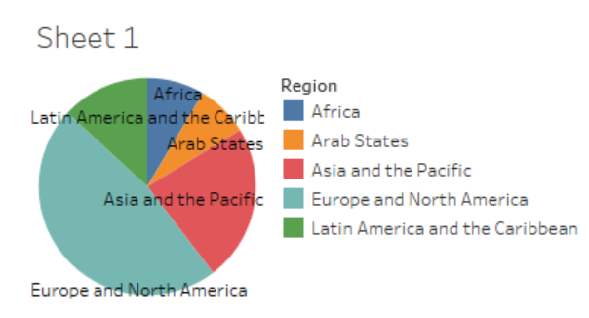

Natural. So, I wanted to show the distribution of all three across all the above mentioned regions. I chose a bar graph to represent it, that way I could even show the number of sites each entity took up. I got this one in my first try. The heritage sites are divided into 3- Cultural, Mixed and

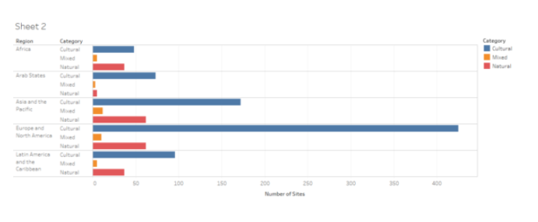

Next, I created a line graph of the number of sites that were inscribed into the World Heritage List throughout the years. I took number of sites and regions in the row and date in the column. I got separate line graphs for each region although it wasn’t my desired result. I wanted one graph showing all region at once. All I had to do was to remove regions from the rows (something so simple) and I wasn’t able to figure that out for long time.

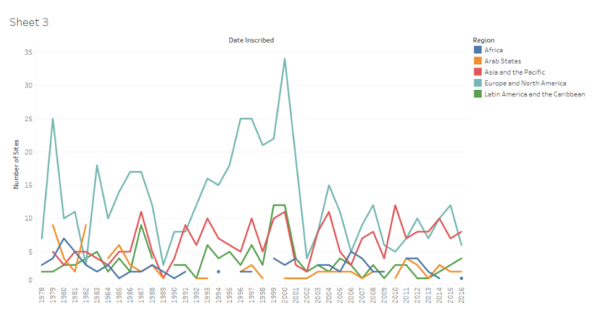

For my final visualization, I wanted to create the same thing that I was inspired by (mentioned above) but I learned that it was something that cannot create using statistics. So, I tried creating something similar- map of the world with each country displaying the total number of heritage site they have. Hovering over the country will display its name and the number of sites. 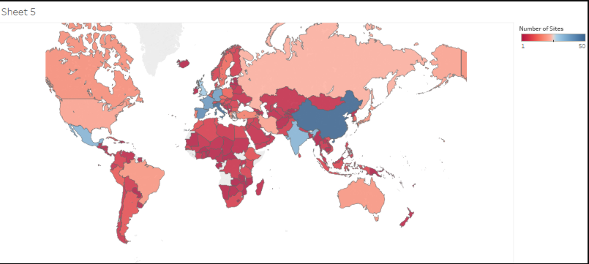Although, I was able to complete some visualization that I had planned to do, I still like to create a visualization where I could show the sites which are included in the

sites which are included in the danger list. To conclude, the first lab was quite useful in getting familiar with Tableau Public and I hope to do more with it.

## 3.4 Technology Stack:

Data flow diagram and technology stack for "Treasures: An In-Depth Analysis of UNESCO World Heritage Sites in Heritage Tableau"

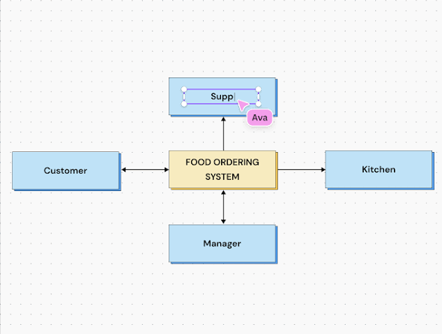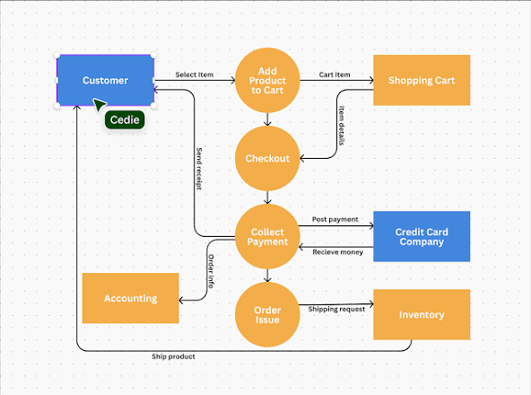

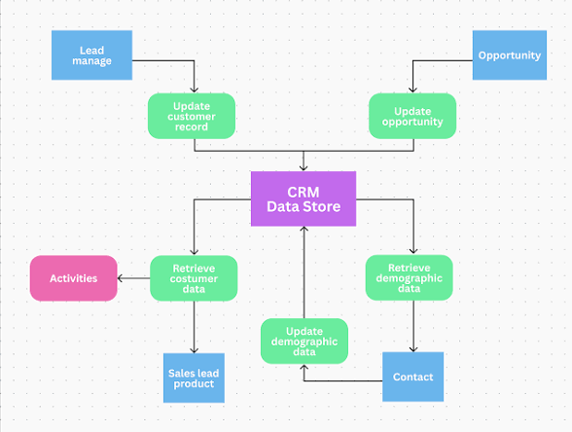

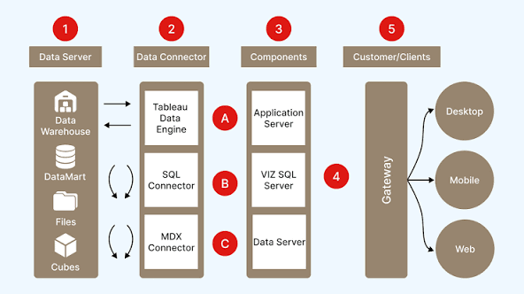

Here's a breakdown of the data flow and the likely technology stack for a project like "Treasures: An In-Depth Analysis of UNESCO World Heritage Sites in Heritage Tableau", focusing on a vertical, top-down approach:

1. Data Sources

* Primary Data Sources:
  + Official UNESCO World Heritage List data: This includes information about individual sites (name, location, inscription date, criteria met, category - cultural, natural, or mixed).
  + UNESCO State of Conservation reports and periodic reporting data: Details on preservation efforts, condition assessments, and monitoring information related to each site.
* Secondary Data Sources (for deeper analysis):
  + Geospatial data: Latitude and longitude coordinates for plotting sites on maps, shapefiles of site boundaries, geographical features data.
  + Risk assessment data: Information on threats to sites, such as wildfires, earthquakes, tsunamis, coral bleaching, vegetation disturbances, potentially from near real-time satellite and geospatial data sources.
  + Economic and social indicators: Data like GDP per capita, population density, tourism trends (to analyze correlations with site preservation or impact).
  + Other relevant external datasets (e.g., climate data, historical records, academic research databases).

2. Data Acquisition

* Connecting to Data Sources: Tableau can connect to various data sources, including flat files (CSV, Excel), relational databases (SQL Server, PostgreSQL, MySQL), cloud platforms (AWS, Google BigQuery, Snowflake), and big data sources.
* Data Extraction (if necessary): Creating extracts from live connections for faster querying and offline access using Tableau's Hyper engine.

3. Data Storage and Processing

* Data Staging/Data Warehouse (Optional but Recommended): A centralized data repository to store and organize the collected data before loading into Tableau. This could be a data warehouse or data lake solution using technologies like SQL databases or cloud storage platforms (AWS S3, Azure Blob Storage).
* Data Cleansing and Transformation: Tools for cleaning and preparing data before analysis in Tableau, potentially using Tableau Prep Builder or other ETL tools to:
  + Remove duplicate data.
  + Handle missing values.
  + Correct inconsistencies.
  + Split and combine fields.
  + Change data types.
  + Perform aggregations and groupings.
  + Build relationships between datasets.

4. Data Analysis and Visualization (Tableau)

* Tableau Desktop: Used by analysts and developers to:
  + Connect to prepared data sources.
  + Define data models, including hierarchies and relationships.
  + Perform calculations and data transformations (e.g., Level of Detail expressions, Table Calculations).
  + Design interactive visualizations, including charts, graphs, maps, and dashboards.
  + Create worksheets and combine them into dashboards and stories.
* Tableau Server/Cloud: For publishing, sharing, and managing the dashboards and data sources.
  + Provides a centralized platform for collaboration, secure access, and version control.
  + Allows users to explore, filter, and interact with the visualizations.
* VizQL Server: Translates user interactions into database queries and generates visualizations from the data.
* Data Engine (Hyper): Tableau's in-memory engine for fast data ingestion and analytical querying on large datasets.

5. Sharing and Collaboration

* Tableau Server/Cloud: Enables users to access published dashboards through web browsers or mobile devices.
* Tableau Mobile: Access dashboards from mobile devices.
* Embedded Analytics: Dashboards can be embedded into other applications or websites.

6. Technology stack summary

* Data Acquisition: Various data connectors (built-in in Tableau) for relational databases (e.g., MySQL, PostgreSQL, Oracle, SQL Server), cloud data platforms (e.g., Google BigQuery, Snowflake, Amazon Redshift), flat files (Excel, CSV) and big data sources.
* Data Storage (if applicable): SQL databases, cloud storage solutions (e.g., AWS S3, Azure Blob Storage).
* Data Preparation & Transformation: Tableau Prep Builder, ETL tools.
* Data Analysis & Visualization: Tableau Desktop, Tableau Server/Cloud.
* Data Engine: Tableau's Hyper engine.
* Mapping (within Tableau): Tableau's mapping capabilities, potentially leveraging latitude and longitude coordinates in the dataset to visualize sites.
* Reporting: Tableau Dashboards and Stories.

This vertical data flow diagram moves from the raw data sources at the top, through the various stages of processing and analysis, to the final visualization and sharing of insights at the bottom, using Tableau and related technologies

4.Project Design:

**1. Goals**

* Visualize UNESCO World Heritage Sites geographically, highlighting distribution and key characteristics like inscription date, criteria, and threats.
* Analyze trends in World Heritage status, identify patterns, and correlate data from external sources for deeper insights.
* Provide a user-friendly and interactive platform for exploring and understanding World Heritage.

**2. Deliverables**

* Interactive Tableau Dashboards: Dashboards on geographical distribution, temporal trends, conservation status, risks and threats, and other relevant themes.
* Data Model: A well-defined and documented data model optimized for performance in Tableau.
* Project Documentation: Covering data sources, methodologies, analysis findings, and dashboard design choices.

**3. Phases**

* **Phase 1:** Data Acquisition & Preparation:
* Identify and gather all necessary data sources.
* Cleanse and transform data for consistency and accuracy.
* **Phase 2:** Core Dashboard Development:
* Develop and test initial dashboards focusing on core themes like geographical distribution, site categories (cultural, natural, or mixed), and inscription year trends.
* Establish a data model and optimize performance.
* **Phase 3:** Advanced Analysis & Enhancements:
* Incorporate external data (e.g., risk assessment data, socio-economic indicators) for advanced analysis.
* Refine existing dashboards and create new ones based on the extended analysis.
* **Phase 4:** Feedback, Refinement & Deployment:
* Gather feedback from potential users.
* Refine dashboards based on feedback.
* Deploy dashboards to Tableau Server/Cloud for sharing and access.

**4. Risks and mitigation**

* Data Availability and Quality: Validate the availability and quality of required data early in the project. Develop robust data cleaning processes.
* Technical Expertise: Ensure the team has sufficient expertise in Tableau and data analysis or engage experts if needed.
* Performance Issues: Optimize dashboards for performance by using extracts, efficient filters, and minimizing the number of objects, especially when dealing with large datasets.

**5. Milestones**

* Project Kick-off and Planning.
* Data Sources Identification and Acquisition.
* Initial Data Model and Core Dashboards Completed.
* Advanced Analysis and Dashboards Completed.
* Feedback Gathering and Dashboard Refinement.
* Final Dashboards Published and Documented.
* Project Closure.

4.1 Problem Solution Fit:

Problem solution fit for "Treasures: An In-Depth Analysis of UNESCO World Heritage Sites in Heritage Tableau"

This section will analyze how the proposed project design, data flow, and technology stack align to solve the identified problem and achieve the desired outcomes.

1. Problem statement

* Lack of Centralized and Visualized Information: Dispersed and often text-heavy information about UNESCO World Heritage Sites can be challenging to access and comprehend for a wider audience. Users may struggle to gain a holistic view of the sites, their characteristics, trends, and the complexities of their preservation and management.
* Difficulty in Identifying Patterns and Trends: Without structured data and appropriate visualization tools, identifying patterns, trends, and correlations across the vast number of World Heritage Sites is cumbersome. For example, understanding geographic distribution patterns, inscription trends over time, or relationships between site characteristics and conservation challenges is difficult.
* Limited Access to Deeper Insights: Information on conservation efforts, risks and threats, or correlations between heritage and socio-economic factors is often fragmented and not easily integrated for comprehensive analysis. This limits the ability to extract deeper insights and inform decision-making in heritage management and preservation.

2. Solution overview

The proposed project addresses these problems through the creation of an interactive and visually engaging platform using Tableau for "Treasures: An In-Depth Analysis of UNESCO World Heritage Sites." This platform will provide:

* Centralized and Visualized Data: A single point of access for comprehensive data about UNESCO World Heritage Sites, presented through intuitive and interactive visualizations.
* Pattern and Trend Analysis: Dashboards and charts that clearly display geographical distribution, historical trends, site categories, conservation status, and potential relationships with other relevant data.
* Deeper Insights and Exploration: The ability to explore detailed information about individual sites, conservation reports, risks and threats, and even integrate external data for advanced analysis. Indeed details the phases of project design

3. Problem-solution fit analysis

The project's design and chosen technology stack are well-aligned to deliver a solution that directly addresses the identified problems:

A. Centralized and visualized information

* Problem: Dispersed and textual information is hard to access and comprehend.
* Solution: The DFD emphasizes collecting data from diverse sources (UNESCO database, geospatial data, conservation reports, external datasets) into a structured format.
* Technology Fit: Tableau's broad data connectivity allows integration of various data sources, while its drag-and-drop interface enables the creation of user-friendly, interactive dashboards, making complex information easily digestible. Tableau Server/Cloud facilitates a centralized platform for sharing these dashboards, addressing the access challenge.

B. Pattern and trend analysis

* Problem: Difficult to identify patterns and trends across a large number of World Heritage Sites.
* Solution: The project design focuses on data cleansing, transformation, and modeling within Tableau to prepare the data for effective analysis.
* Technology Fit: Tableau's powerful data analysis and visualization capabilities allow for the creation of various charts, graphs, maps, and dashboards that highlight trends in inscription dates, geographical distribution, criteria fulfillment, and conservation status. Tableau's calculated fields and level of detail expressions enable deeper analysis and the identification of nuanced patterns within the data.

C. Deeper insights and exploration

* Problem: Fragmented information limits the ability to extract deeper insights and inform decision-making.
* Solution: The DFD and project design allow for integrating additional data sources (e.g., risk assessment data, tourism data) and combining them for more comprehensive analysis.
* Technology Fit: Tableau's data blending capabilities and integration with tools like R or Python for advanced analytics provide the flexibility to incorporate diverse datasets and perform complex statistical analysis, leading to richer insights. Features like drill-down capabilities within Tableau dashboards will allow users to explore specific sites or data points in greater detail. Indeed details the phases of project design

4. Overall alignment

The iterative and phased approach of the project design, coupled with the vertical data flow, ensures that the solution evolves in response to feedback and new data. The technology stack, centered around Tableau, is well-suited for handling the diverse data types and complex visualization needs of the project. Ultimately, the project aims to create a valuable resource for anyone interested in UNESCO World Heritage Sites by providing a platform for exploration, analysis, and deeper understanding.

## 4.2 proposed solution:

Proposed solution: Treasures - An in-depth analysis of UNESCO World Heritage Sites in Heritage Tableau

This proposed solution leverages the strengths of Tableau and data visualization best practices to address the challenges of understanding and appreciating UNESCO World Heritage Sites. The goal is to create an interactive and engaging experience for various audiences, from students and researchers to the general public.

1. Data sources and collection

* Primary Data Sources:

Official UNESCO World Heritage List data (names, locations, criteria, inscription dates, risk status)

>UNESCO State of Conservation reports and other reports related to heritage preservation and management.

* Secondary Data Sources:
* Geospatial data for precise site location and mapping.
* Relevant demographic, environmental, and socio-economic data (climate data, tourism trends, risk assessment data, etc.).
* Data Collection Methods:

**>**Utilize Tableau's data connectors to access readily available data sources (e.g., spreadsheets, databases).

**>**Implement web scraping for unstructured data or information from various websites, adhering to ethical guidelines.

**>**Manually enter data for smaller datasets or for quality control.

2. Data preparation and cleaning

* Tableau Prep Builder: Use this tool to clean, shape, and combine data from different sources.
* Key Techniques:
* Handle missing values using appropriate imputation or deletion methods.
* Standardize column names, data types, and formats for consistency.
* Remove duplicate or erroneous entries.
* Create calculated fields for data enrichment and further analysis.

3. Visualization and analysis with Tableau

* Tableau Desktop:
  + Interactive Dashboards: Design a suite of interactive dashboards covering different aspects of World Heritage Sites, for example:
    - Geographic Distribution: Map-based visualizations showcasing site locations, potentially color-coded by type or risk status.
    - Temporal Trends: Line charts illustrating the growth of the World Heritage List over time or the impact of events on site preservation.
    - Categorical Breakdown: Bar charts, treemaps, or stacked bar charts showing the proportion of cultural, natural, and mixed sites, possibly broken down by region or country.
    - Conservation and Risks: Visualizations highlighting sites facing threats or in need of conservation efforts, potentially incorporating time-series analysis.
    - Relationship Analysis: Scatter plots and other visualizations exploring the correlation between various factors like tourism revenue and conservation spending.
  + Calculated Fields and Parameters: Utilize Tableau's calculation capabilities and parameters to enable dynamic analysis and exploration by users.
* Tableau Server/Cloud: Publish and manage the interactive dashboards, facilitating secure access and collaboration.

4. Proposed dashboard examples

* World Heritage Map: An interactive map allowing users to explore sites by location, filter by type (cultural, natural, mixed), view site details on hover, and potentially highlight sites facing risks or specific conservation challenges.
* Inscription Trends Dashboard: A set of visualizations showing the historical growth of the World Heritage List, with options to filter by region or country to observe specific trends in inscription.
* Conservation Status Tracker: Visualizations presenting the conservation status of sites over time, indicating improvements or decline, potentially linking to summary reports on specific conservation interventions.
* Impact Analysis Dashboard: Visualizations exploring the relationship between World Heritage Sites and their surrounding environments or communities, using data on tourism, socio-economic indicators, or climate change impact.

5. Technology stack summary

* Data Acquisition: Python (Beautiful Soup, requests), Tableau Data Connectors, potentially other ETL tools.
* Data Storage: SQL Databases (PostgreSQL, MySQL), cloud storage (AWS S3, Azure Blob Storage).
* Data Preparation & Transformation: Tableau Prep Builder, Python (Pandas).
* Data Analysis & Visualization: Tableau Desktop, Tableau Server/Cloud.
* Data Engine: Tableau Hyper engine.
* Geospatial Capabilities: Tableau mapping features, potentially supplemented by external GIS software like QGIS.

6. Success metrics

* User Engagement: Track website traffic, dashboard usage, and user interactions to gauge user interest and satisfaction.
* Information Accessibility: Measure the ease with which users can find and interpret information on the dashboards.
* Insights Generated: Qualitative assessment of the depth and quality of insights derived from the platform.
* Community Impact: Monitor how the platform contributes to increased awareness and appreciation of World Heritage Sites

## 4.3 Solution Architecture:

This solution architecture outlines the components and their interactions for developing and deploying the "Treasures" project. It adheres to best practices in data warehousing, visualization, and security, utilizing the Tableau platform effectively.

1. Architectural overview

The architecture follows a layered approach, moving from data sources to end-user consumption of interactive dashboards, [upGrad emphasizes the layered approach](https://www.upgrad.com/blog/tableau-architecture/" \t "_blank) with Tableau playing a central role in the analysis and visualization stages.

2. Data source layer

* UNESCO World Heritage Centre Database: The primary source for official UNESCO data. This is typically accessed through web services, APIs, or direct database connections (depending on availability).
* Geospatial Data Repositories: Databases containing geographic information like shapefiles, points of interest, and boundaries, often available through open data platforms or specialized services.
* Conservation Reports and Archives: Documents and records providing detailed information on the state of conservation of sites. These may require document analysis and extraction techniques (e.g., natural language processing, data extraction tools).
* External Datasets: Various external data sources, such as climate data, socio-economic indicators, tourism trends, and relevant research, are accessed using dedicated connectors or through APIs.

3. Data integration and processing layer

* ETL (Extract, Transform, Load) Process: A robust ETL process is essential for extracting data from various sources, cleansing it, and transforming it into a format suitable for analysis in Tableau. [Applied AI Course describes the steps involved in the process](https://www.appliedaicourse.com/blog/tableau-architecture/)
  + Data Extraction: Python scripting, web scraping libraries (e.g., Beautiful Soup), or specialized ETL tools (e.g., Tableau Prep Builder, Apache NiFi) to gather raw data from the disparate sources.
  + Data Cleansing and Transformation: Tableau Prep Builder or Python scripts (using Pandas) to clean the data (e.g., removing duplicates, handling missing values, correcting inconsistencies). Data transformations involve restructuring data, creating new calculated fields, and ensuring data quality.
  + Data Loading: Load the prepared data into the data warehouse or the Tableau Data Engine (Hyper) for optimized analysis.
* Data Warehouse (Optional but Recommended): A centralized data warehouse (e.g., SQL Server, PostgreSQL, cloud-based data warehouses like Snowflake or Amazon Redshift) for storing and organizing the integrated data. This acts as a single source of truth, improving data consistency and reliability.

4. Tableau layer

* Tableau Desktop: Data analysts use Tableau Desktop to connect to the prepared data sources (live or extracts), create data models, perform calculations, design visualizations, and build interactive dashboards.
  + Data Models: Define relationships between tables, create hierarchies, and optimize data sources for performance.
  + Calculated Fields: Create custom calculations for deriving new insights and metrics.
  + Visualizations: Create a wide range of charts, graphs, maps, and other visual representations to effectively communicate findings.
  + Dashboards: Combine multiple visualizations into interactive dashboards, incorporating filters, parameters, and actions to enable dynamic exploration.
* Tableau Server/Cloud: Serves as the central platform for publishing, sharing, and managing the developed dashboards and data sources.
  + Publishing and Sharing: Dashboards and workbooks created in Tableau Desktop are published to Tableau Server/Cloud.
  + User Management and Security: Manage user access, define roles and permissions, and implement security measures (e.g., row-level security, data encryption).
  + Data Refresh and Scheduling: Automate data refresh processes to ensure dashboards display up-to-date information.
  + Collaboration: Facilitate collaboration among users through comments, subscriptions, and embedding options.
  + Gateway: Acts as the entry point for all incoming requests, routing them to the appropriate server processes.
  + VizQL Server: Translates user interactions into visual queries and generates visualizations.
  + Data Server: Manages data connections and metadata, enabling efficient data access.
  + Data Engine (Hyper): Tableau's in-memory data engine for fast query performance, especially with extracts.
  + Repository: Stores metadata, user information, permissions, and configuration settings.
  + File Store: Stores extracts, workbooks, and other files associated with the project.
* Tableau Clients: End-users access and interact with the dashboards through various clients:
  + Web Browsers: Access dashboards securely through Tableau Server/Cloud web interface.
  + Tableau Mobile App: Access and interact with dashboards on smartphones and tablets.

5. Deployment model

* Tableau Cloud (Recommended for Ease of Management): If the organization prefers a fully managed, scalable solution with lower infrastructure overhead, Tableau Cloud is the ideal choice. It provides automatic scaling, high availability, and global accessibility.
* Tableau Server (On-Premises or Cloud VMs): If there are specific security requirements, data residency concerns, or a need for more control over the environment, deploying Tableau Server on-premises or on cloud virtual machines (e.g., AWS EC2, Azure VMs, Google Cloud Platform) might be preferred. This offers greater customization but requires managing the underlying infrastructure.

6. Security and governance

* Authentication and Authorization: Implement robust access controls using role-based permissions, integration with enterprise identity providers (e.g., LDAP, Active Directory), and Multi-Factor Authentication (MFA).
* Data Encryption: Ensure data is encrypted both at rest (e.g., in databases, file storage) and in transit (using SSL/TLS protocols).
* Network Security: Implement firewalls, security groups, and network segmentation to protect the Tableau environment. [upGrad details how Tableau provides robust security against unauthorized access](https://www.upgrad.com/blog/tableau-architecture/" \t "_blank)
* Data Governance: Establish clear data governance policies for data quality, metadata management, and responsible data usage. Publish certified data sources to ensure consistency and trust.
* Monitoring and Auditing: Regularly monitor server performance, user activity, and security logs to identify and address potential issues.

7. Performance optimization

* Extracts: Utilize Tableau Data Extracts (Hyper) whenever possible to improve query performance, reduce the load on data sources, and enable faster dashboard interactions.
* Data Modeling: Design efficient data models within Tableau using relationships (rather than blending unnecessarily) to simplify queries and improve performance.
* Filters: Optimize filters, minimize their number, and utilize context filters or parameters strategically to enhance dashboard responsiveness.
* Dashboard Design: Follow best practices for dashboard design, focusing on clarity, simplicity, and minimizing unnecessary elements that can impact loading times.

This solution architecture provides a flexible and scalable framework for building and deploying the "Treasures" project, ensuring data integrity, security, and optimal performance for users exploring the world of UNESCO World Heritage Sites.

5.Project Planning And Scheduling:

5.1 Project planning  **:**

1. Defining project scope and goals

* Project Scope: Clearly define the boundaries of the project, including the specific UNESCO World Heritage Sites to be included, the types of data to be collected and analyzed, and the extent of the visualizations to be created. Will the project focus solely on cultural sites, or will it encompass natural and mixed sites as well? What external datasets will be included? [Tableau documentation emphasizes defining project scope](https://help.tableau.com/current/blueprint/en-us/bp_project_planning.htm)
* Project Goals: Establish SMART (Specific, Measurable, Achievable, Relevant, and Time-bound) goals. For example:
  + Create a set of interactive Tableau dashboards visualizing key trends and insights from UNESCO World Heritage Site data within 3 months.
  + Increase user engagement with the visualizations by 20% compared to previous data sources.
  + Enable users to easily explore relationships between geographical locations, site characteristics, and conservation status. [CourseDrill emphasizes defining clear outcomes](https://coursedrill.com/tableau-projects/" \t "_blank)

2. Work breakdown structure (WBS)

Break down the project into smaller, manageable tasks and subtasks. A typical WBS for this project might include:

* Phase 1: Project Initiation & Planning
  + Define project scope, goals, and objectives.
  + Identify and define roles and responsibilities.
  + Develop a detailed project plan and timeline.
  + Set up project management tools and communication channels.
* Phase 2: Data Acquisition & Preparation
  + Identify and gather required data sources (UNESCO database, geospatial data, conservation reports, external datasets).
  + Perform data cleansing, transformation, and quality assurance.
  + Create a data model and ensure data integrity.
  + Document data sources, preparation steps, and any limitations.
* Phase 3: Dashboard Development & Iteration
  + Design and build initial visualizations and dashboards based on defined project goals.
  + Conduct internal reviews and gather feedback from stakeholders.
  + Iteratively refine dashboards based on feedback and new insights. [Coursera describes the iterative approach of data visualization projects](https://www.coursera.org/learn/dataviz-project" \t "_blank)
  + Develop interactive elements (filters, parameters, actions) to enhance user experience.
* Phase 4: Testing & Deployment
  + Test dashboards for accuracy, performance, and user-friendliness.
  + Address any bugs or issues identified during testing.
  + Publish dashboards to Tableau Server/Cloud.
  + Configure data refresh schedules and security settings.
* Phase 5: Documentation & Training
  + Prepare comprehensive documentation (project summary, data sources, methodology, insights).
  + Develop training materials and conduct user training sessions.
  + Gather feedback on documentation and training.

3. Scheduling and estimation

* Task Duration Estimation: Estimate the time required to complete each task using techniques like:
  + Analogous Estimation: Drawing on experience from similar past projects.
  + Expert Judgment: Leveraging the knowledge and experience of the project team and subject matter experts.
  + Three-Point Estimation: Using optimistic, pessimistic, and most likely estimates to calculate a weighted average duration.
* Resource Allocation: Assign resources (team members, software licenses) to each task based on their availability and skill sets.
* Dependencies: Identify and map out task dependencies to determine the critical path of the project.
* Timeline Creation: Create a detailed project timeline using tools like Gantt charts to visualize task durations, dependencies, and milestones. [Tableau provides a guide on making Gantt charts](https://www.tableau.com/learn/articles/how-to/gantt-chart)
* Scheduling Tools: Utilize project management software (e.g., Jira, Asana, Microsoft Project) to manage tasks, track progress, and communicate updates.

4. Risk management

* Risk Identification: Identify potential risks that could impact the project schedule, such as data quality issues, technical challenges, or changes in requirements.
* Risk Assessment: Assess the likelihood and impact of each identified risk.
* Risk Mitigation: Develop strategies to mitigate potential risks, such as implementing robust data quality checks, allocating buffer time for technical challenges, and establishing a change management process for managing changes in requirements.

5. Communication and collaboration

* Regular Meetings: Schedule regular project meetings with the team and stakeholders to review progress, discuss challenges, and gather feedback. [Tableau recommends weekly meetings during initial deployment](https://help.tableau.com/current/blueprint/en-us/bp_project_planning.htm)
* Communication Plan: Establish a clear communication plan outlining how information will be shared with the team, stakeholders, and end-users.
* Feedback Loops: Implement mechanisms for gathering and addressing feedback from users to continuously improve the dashboards.

6. Functional And Performance Testing:

6.1. Performmance Testing:

Performance testing evaluates the speed, efficiency, and responsiveness of the Tableau dashboards and reports under various workloads to ensure a smooth and efficient user experience. [Datagaps provides insights into Tableau performance testing](https://www.datagaps.com/blog/tableau-performance-testing-spot-issues/" \t "_blank)

A. Key performance testing areas

* Dashboard Load Times: Measure the time it takes for dashboards to open and render under different conditions. [Datagaps includes dashboard load time as a key performance metric](https://www.datagaps.com/blog/tableau-performance-testing-spot-issues/" \t "_blank)
* Filter and Interactivity Response Times: Assess the responsiveness of filters, parameters, and other interactive elements.
* Data Refresh Performance: Evaluate the efficiency of data refreshes and the impact on dashboard availability.
* Scalability: Test how the dashboards and Tableau Server/Cloud environment perform under increasing user load and data volumes. [Tableau documentation includes load testing as part of server management](https://help.tableau.com/current/blueprint/en-us/bp_load_testing.htm)
* Resource Utilization: Monitor server resource consumption (CPU, memory) to identify bottlenecks.

B. Performance testing process

1. Define Performance Requirements: Establish clear performance goals and Service Level Agreements (SLAs), such as acceptable load times or response times.
2. Test Environment Setup: Create a test environment that mirrors the production environment, including hardware, software, and data volume. Tableau documentation recommends using an identical test environment for load testing
3. Workload Modeling: Simulate realistic user workloads and behaviors, including concurrent users, common interactions (viewing, filtering, navigating), and peak usage scenarios.
4. Test Execution: Execute performance tests using specialized tools.
5. Monitoring and Analysis: Monitor key performance metrics (e.g., response time, throughput, error rates) during test execution and analyze the results to pinpoint performance bottlenecks.
6. Optimization and Retesting: Identify areas for optimization (e.g., data source optimization, query tuning, dashboard design improvements), implement changes, and retest to validate improvements. Datagaps suggests optimizing data models and queries based on stress test results

C. Tools for performance testing

* Tableau Performance Recorder: A built-in Tableau tool for identifying performance bottlenecks within workbooks. [Datagaps describes how the Tableau Performance Recorder works](https://www.datagaps.com/blog/tableau-performance-testing-spot-issues/" \t "_blank)
* TabJolt: A Tableau-specific load and performance testing tool designed for testing Tableau Server scalability. [Tableau provides information on TabJolt](https://www.tableau.com/blog/introducing-tabjolt-point-and-run-load-testing-solution-tableau-server-38604)
* Datagaps BI Validator: Includes functionality for stress testing Tableau reports by simulating concurrent users and measuring key performance indicators. [Datagaps details the stress test plan feature of BI Validator](https://www.datagaps.com/blog/tableau-performance-testing-spot-issues/" \t "_blank)
* Apache JMeter: An open-source tool for load and performance testing, which can be adapted for Tableau testing.
* Third-Party Monitoring Tools: Tools like Scout, Sitescope, Zabbix, Splunk, or Graylog can be used to monitor server and application performance during testing and in production.

7.Results:

7.1: Screenshot Output: The visualization is the number of world heritage sites in different countries. Made it into a bubble chart.

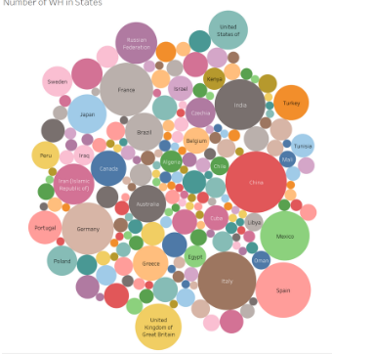

The visualization is the number of world heritage sites in different countries. Made it into a bubble chart.

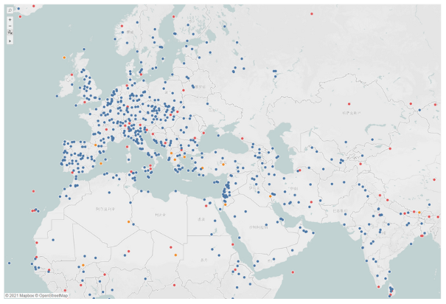

The first visualization is a map. edit the map according to the location of the heritage. Different colors indicate different categories, and different sizes are displayed on the map according to the area of the heritage.

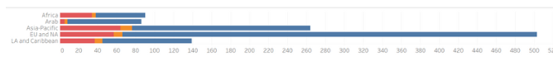This is a bar graph showing the number of different types of World Heritage Sites in different regions.

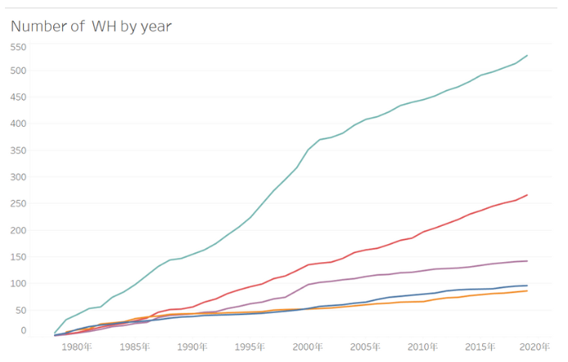

This is a line graph, which is the number of world heritage sites and the changes in the area of world heritage sites over the years.For world heritage in china data, not only Tableau is used, but SotryMapJS, TimelineJS is used to combine data, stories, and timelines or maps.

8.Advantages and Disadvantages:

Advantages

* Powerful visualization and storytelling: Tableau allows for the creation of interactive and visually appealing dashboards and reports that can effectively communicate insights about UNESCO sites.
* Ease of Use: Its intuitive interface and drag-and-drop functionality make it accessible for both technical and non-technical users to explore and analyze data related to heritage sites.
* Data Integration and Exploration: Tableau can connect to diverse data sources, such as spreadsheets, databases, and cloud platforms, enabling comprehensive analysis of heritage site data. It facilitates exploring data dynamically, asking questions, testing hypotheses, and deriving meaningful insights.
* Real-Time Analytics: Connecting to live data sources can provide real-time updates and dynamic analysis of heritage information, [according to Analytics Vidhya](https://www.analyticsvidhya.com/blog/2024/03/what-is-tableau-its-application-and-benefits-in-data-science/).
* Collaboration and Sharing: Workbooks and dashboards can be published to Tableau Server or Tableau Online, fostering collaboration and secure sharing of heritage insights.
* Highlighting Key Information: Tableau's features like color cues, shapes, and size can be used to emphasize crucial aspects of UNESCO sites, aiding in quick understanding and analysis.
* Tracking and Analyzing Trends: Tableau can help identify patterns and trends in heritage data over time, crucial for understanding site management challenges and effectiveness.

Disadvantages

* Cost and Scalability: Tableau can be expensive for enterprise-level solutions, and while scalable, it requires careful consideration of licensing and infrastructure needs.
* Need for Data Expertise: While easy to use, creating highly effective visualizations requires creativity, strategic planning, and understanding of data analysis principles.
* Customization Limitations: Tableau's reliance on pre-defined chart types may restrict the creation of highly specialized or custom visualizations, [says AbsentData](https://absentdata.com/advantages-and-disadvantages-of-tableau/).
* Potential for Misrepresentation: Poorly designed visualizations can be cluttered, misleading, or difficult to interpret, especially for complex heritage data.
* Overemphasis on Certain Values: Focusing on specific data points or values can neglect other important aspects of a heritage site, potentially leading to a biased or incomplete understanding.
* Dependence on Data Availability and Quality: The accuracy and effectiveness of the analysis depend heavily on the completeness, reliability, and quality of the underlying heritage data.
* Potential for "Visual Overload": Using too many visualizations or elements can overwhelm the audience and hinder effective communication.

9. Conclusion:

Tableau offers significant advantages for exploring, visualizing, and analyzing UNESCO World Heritage Sites, particularly for communicating complex information to a broad audience and facilitating collaborative efforts. However, users should be mindful of its potential drawbacks, such as cost, the need for careful data handling and visualization design, and the importance of contextualizing the data to avoid biased or incomplete interpretations. By considering both the benefits and limitations, Heritage Tableau can be a powerful tool for promoting understanding, preservation, and sustainable management of these invaluable sites.

10. Future Scope:

Future scope of Tableau in analyzing UNESCO World Heritage Sites

The future scope of using Tableau for analyzing UNESCO World Heritage sites is immense and will likely involve the integration of emerging technologies and a shift towards more dynamic, collaborative, and accessible approaches.

Here's a breakdown of potential future trends and applications:

1. Advanced Analytics and AI/ML integration

* Predictive Modeling: Utilizing AI/ML to predict potential threats to heritage sites (e.g., climate change impacts, visitor damage, deterioration patterns), allowing for proactive preservation efforts.
* Automated Damage Detection and Monitoring: Combining AI-powered image analysis with Tableau visualizations to automatically detect and track damage over time, potentially including drone or satellite imagery for remote monitoring.
* Deep Learning for Cultural Heritage Analysis: Applying deep learning algorithms to analyze large datasets of heritage information, including images, texts, and 3D models, to reveal insights about architectural styles, materials, and historical changes.
* Understanding Visitor Behavior and Engagement: Leveraging AI/ML to analyze visitor data (e.g., through virtual tours, social media) to tailor experiences, improve site management, and enhance educational programs.

2. Dynamic and Interactive Storytelling and Education

* Virtual and Augmented Reality Experiences: Integrating Tableau visualizations with VR/AR environments to create immersive and interactive experiences for visitors, allowing them to explore sites in unprecedented ways and learn about their history and significance.
* Gamification and Interactive Learning: Creating engaging educational content for heritage sites using gamified experiences within Tableau dashboards or connected applications to boost visitor engagement and learning.
* Personalization and Customization: Using Tableau to create personalized experiences and content for visitors based on their interests, preferences, and interaction history.

3. Data Integration, Standardization, and Collaboration

* Cross-Platform Interoperability: Enhancing interoperability between Tableau and other heritage management platforms, such as Historic Building Information Modeling (HBIM) and Geographical Information Systems (GIS), to create a unified data ecosystem.
* Standardized Data Formats: Promoting the adoption of standardized data formats and metadata for cultural heritage data to facilitate data sharing and analysis across different institutions and countries.
* Open Access and Collaboration Platforms: Developing platforms that enable researchers, conservationists, and the public to access, share, and collaborate on heritage data and visualizations, fostering interdisciplinary and international cooperation.

4. Addressing Challenges and Promoting Ethical Practices

* Data Quality and Integrity: Developing strategies and tools to ensure the quality, accuracy, and completeness of data used for analysis and visualization.Digital Preservation and Accessibility: Addressing challenges related to long-term preservation, accessibility, and potential biases in data and AI/ML models.
* Balancing Technological Advancement with Authenticity: Striving for a balance between leveraging cutting-edge technologies and respecting the authenticity and cultural context of heritage sites. In conclusion, the future of Tableau in analyzing UNESCO World Heritage sites lies in embracing technological advancements, fostering collaboration and data sharing, and prioritizing ethical considerations in the pursuit of preserving and promoting our shared cultural legacy.

11. Appendix:

Source code:   
import sqlite3

import pandas as pd

import os *# To check if the database file exists*

*# --- Configuration ---*

DATABASE\_NAME = 'unesco\_heritage\_large.db'

CSV\_FILE\_PATH = 'large\_unesco\_data.csv' *# Make sure this file exists in the same directory*

TABLE\_NAME = 'sites\_large'

*# Define column mapping from CSV to desired database column names*

*# Adjust these based on your actual CSV file's column names*

COLUMN\_MAPPING = {

'name': 'name',

'country\_name': 'country', *# Example: CSV might have 'Country name'*

'date\_inscribed': 'year\_inscribed', *# Example: CSV might have 'date\_inscribed'*

'category\_long': 'category' *# Example: CSV might have 'category\_long'*

*# Add other columns you want to import and their mappings*

}

*# --- Database Connection and Table Creation ---*

conn = sqlite3.connect(DATABASE\_NAME)

cursor = conn.cursor()

*# Create a table for UNESCO sites*

*# Adjust the table schema based on the columns you are importing*

cursor.execute(f'''

CREATE TABLE IF NOT EXISTS {TABLE\_NAME} (

id INTEGER PRIMARY KEY AUTOINCREMENT,

name TEXT NOT NULL,

country TEXT NOT NULL,

year\_inscribed INTEGER,

category TEXT

-- Add other columns here as TEXT, INTEGER, REAL, etc.

)

''')

conn.commit()

print(f"Database '{DATABASE\_NAME}' and table '{TABLE\_NAME}' ensured.")

*# --- Load and Insert Data from CSV ---*

try:

*# Use chunksize for very large files to avoid memory issues*

*# Adjust chunksize based on your system's memory and file size*

chunk\_size = 10000

*# Read the CSV file in chunks*

chunks = pd.read\_csv(CSV\_FILE\_PATH, chunksize=chunk\_size)

for i, chunk in enumerate(chunks):

print(f"Processing chunk {i+1}...")

*# Rename columns to match the database table schema*

*# Drop columns not needed or not mapped*

df\_to\_insert = chunk.rename(columns=COLUMN\_MAPPING)

df\_to\_insert = df\_to\_insert[[col for col in COLUMN\_MAPPING.values() if col in df\_to\_insert.columns]]

*# Ensure correct data types if needed (e.g., convert year string to int)*

*# Example: if 'year\_inscribed' is read as object/string, convert it*

if 'year\_inscribed' in df\_to\_insert.columns:

df\_to\_insert['year\_inscribed'] = pd.to\_numeric(df\_to\_insert['year\_inscribed'], errors='coerce').fillna(0).astype(int)

*# Insert data from DataFrame chunk into the SQLite table*

*# if\_exists='append' adds to the existing table*

df\_to\_insert.to\_sql(TABLE\_NAME, conn, if\_exists='append', index=False)

print(f"Chunk {i+1} inserted.")

conn.commit()

print(f"Data from {CSV\_FILE\_PATH} successfully loaded into {DATABASE\_NAME}.")

except FileNotFoundError:

print(f"Error: CSV file '{CSV\_FILE\_PATH}' not found.")

print("Please make sure the CSV file exists in the same directory or provide the correct path.")

except KeyError as e:

print(f"Error: Missing column in CSV or incorrect mapping: {e}")

print("Please check your COLUMN\_MAPPING to ensure it matches the CSV and database schema.")

except Exception as e:

print(f"An unexpected error occurred: {e}")

finally:

conn.close()

print("Database connection closed.")

Dataset link:

<https://mail.google.com/mail/u/0?ui=2&ik=56899d1404&attid=0.1&permmsgid=msg-a:r392177660685064187&th=198adf2c9ec5e1cd&view=att&disp=safe&realattid=f_mecvgvav0&zw>

Github link:

<https://github.com/indu-09reddy/Data-Analytics-With-Tableau>

Demo Video:

<https://www.youtube.com/watch?v=lOzxUVCCSug&list=PPSV>